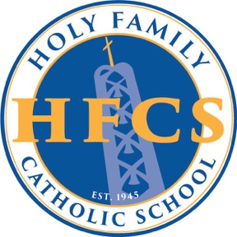

APPLICATION TO RECEIVE PARISH RATE DISCOUNT
This form is only applicable to families who are Catholic
and registered, active members of a Catholic church in the Diocese of Fort Worth,
other than Holy Family Catholic Church.

DO NOT use this form if you belong to Holy Family Catholic Church.

To apply for the parish rate discount, do the following:
- Complete this form in its entirety.

- Submit the completed form to your home parish. Your pastor will use their sole discretion in defining active membership.

- Return the approved form to the school’s Business Manager, Kelli Tull at ktullwaldrop@holyfamilyfw.org, no later than April 15, 2026.
If an approved form is not received by April 15, 2026, you will be required to pay the tuition rate in effect for the 2026 – 2027 school year.
If you have any questions do not hesitate to contact me at 817-737-4201, x109.

Lisa Griffith
Director of Development and Enrollment

Parent/Legal Guardian Name (Printed) |  | Parent Signature
Student Name(s) and Grade(s)
Parish Name |  | Parish Location

I certify that the family listed above is a registered, active member of our parish and therefore is eligible to receive the parish rate discount offered by Holy Family Catholic School for the 2026 – 2027 school year.
r Signature |  | Date

